**Manual camera control**

**Mode A**

In this mode the previously saved camera positions including the zoom level (positions 1 - 8) can be approached again.

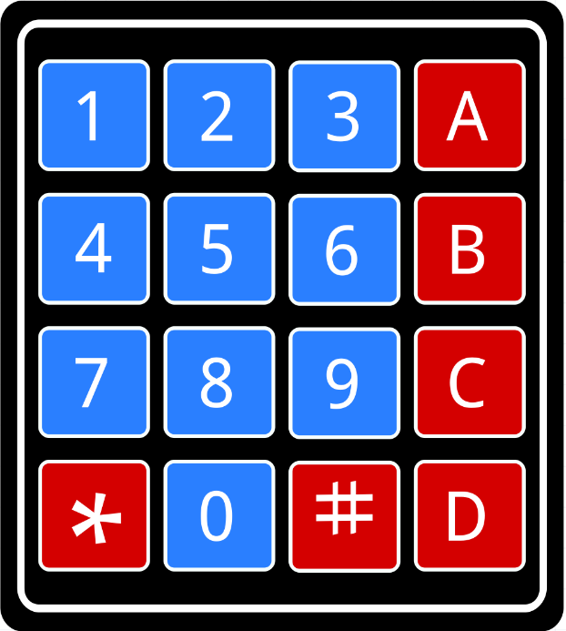

Button 1: Position 1

**X**

Button 2: Position 2

Button 3: Position 3

Button 4: Position 4

**X**

**X**

Button 5: Position 5

Button 6: Position 6

Button 7: Position 7

Button 8: Position 8

**X**

**X**

**X**

**X**

**Mode B**

In this mode, the camera can be moved **step by step** in the selected direction. It is also possible to use the zoom function **step by step**.



**X**

**X**

**X**

Button 2: Up

**X**

Button 4: Left

Button 6: Right

Button 8: Down

**X**

**X**

**X**

Button *: Zoom in

Button #: Zoom out

**X**

**X**

**Manual camera control**

**Mode C**

In this mode, the camera can be moved **continuously** in the selected direction. It is also possible to use the zoom function **continuously**. Each camera movement must be **stopped manually**.



**X**

**X**

**X**

Button 2: Up

**X**

Button 4: Left

Button 5: Stop

Button 6: Right

**X**

**X**

Button 8: Down

Button *: Zoom in

Button #: Zoom out

**X**

**X**

**Mode D**

In this mode the current camera position including the existing zoom level can be saved. Possible positions are 1 - 8.



**X**

Button 1: Position 1

**X**

Button 2: Position 2

Button 3: Position 3

Button 4: Position 4

**X**

**X**

Button 5: Position 5

Button 6: Position 6

Button 7: Position 7

Button 8: Position 8

**X**

**X**

**X**